**Smart Dustbin –An Efficient Waste Management System**

**Mazhar Ibna Zahur, Md.Saidur Rahman**

Computer Science And Engineering Discipline

Khulna University, Khulna, Bangladesh

**Abstract:**

In the recent years, Urbanization has increased tremendously in our country. At the same times waste production are increased rapidly. But collecting waste in efficient way has become more difficult as the increasing number of waste production. This paper is a way to achieve an efficient way of this problem. In this paper, smart bin is built on a microcontroller based platform Aurdino board which is interfaced with GSM modem, several Ultrasonic sensors and GPS position tracker. The whole system is environment friendly and powered by Solar panel. Several Ultrasonic Sensors are used for measuring the status of the dustbin and predict the size of the bin. The number of Ultrasonic sensors depends on the size of the bin. Aurdino will be programmed in such way that when the Ultrasonic sensors changes their status, it will calculate used space and display the remaining empty space of the bin. A threshold status is set depending on the structure and size of the bin. Once the garbage reaches the threshold level of the top sensors, it will trigger the GSM modem which will sent data to a web page. Web page will developed using PHP and database. Web page will store data for future waste management statistics and when it receives signal from GSM modem immediately it will sent to the responsible authority. Once the dustbin is squashed, people can reuse them. GPS tracker will be used for tracking the current location of the bin, which can be used for future work as well. Once these smart bins are implemented on a large scale, traditional bins can be reused.

**Keywords:** Aurdino, GSM modem, Ultrasonic sensor, GPS location tracker, Web page, Solar panel

1. **INTRODUCTION**

Most of the urban cities and towns in Bangladesh are not well designed to facilitate the proper garbage system. Moreover urban peoples are moving towards cities and it rapidly putting the pressure on the existing infrastructure which is not expanding at the time. In the recent year ours govt. motto is “DIGITAL BANGLADESH”. A smart waste management system can give a proper way to fulfill its dream, as proper waste management

system can lead people in hygienic life and make the air fresh.

Our proposed system provide an IT based solution to garbage collection greater accessibility, planning appropriately for disposing process and at the same time enabling collection of garbage generation data. Data will be used for future statistics, which areas bins are full rapidly and which areas are slowly. Using the data we can rearrange the bins locations for efficient use. Furthermore it will solve some related problems:-

1. Clean environment system.
2. Efficient in terms of time and fuel cost.
3. Provide data collection facility on how much a city generate garbage.
4. **DESCRIPTION**

This proposed system has been divided into three layers:

1. Dustbin Layer: - This layer consists of GSM enabled Arduino R3 board which powered by a 9V, 220 mA Solar panel. A 12V Solar battery will placed in the device. Battery receives power from Solar panel and store it. Battery serves power the Arduino. The Arduino board interfaced with a GSM module, a GSM Antenna, a GPS receiver and several Ultrasonic sensors depending on the size of the bin. For small size of bin, one Ultrasonic sensor placed top of the bin and three vertically placed, which indicates the level of the bin. For bigger size two or three Ultrasonic sensors placed top of the bin. Two small tinny LED light placed top view of the bin, one red and other green. Red light will turn on when bin is full, otherwise green light turns on. When red light turns on, Arduino board sends signals to the GSM modem. Arduino board also sends signal, when any of the Ultrasonic sensors changes its status. At last GSM modem sends data to the server system.
2. Server Layer: - This layer consists of PHP web page and a Database system. Web page receives data from the GSM modem and it shows current visual view of each bin. Database stores each bins full and empty time, date and locations. When any of the bin is full, it sends bin’s location to the dust collector’s mobile. When collector collect dust from the bin, server will update the bin status.
3. Mobile Application Layer: - This layer provide a Mobile Application, which helps the dust collector to collect dust more efficiently. This Application receives data from the server. If it receives more than one bin’s full signals, it automatically arrange the locations in shortest path using algorithm. And show the visual diagram.
4. **DESIGN**

Our smart bin is designed on an Arduino board Ultrasonic sensors, GPS module, GSM modem and Eco friendly power supply. Block diagram for our smart dustbin is shown below:

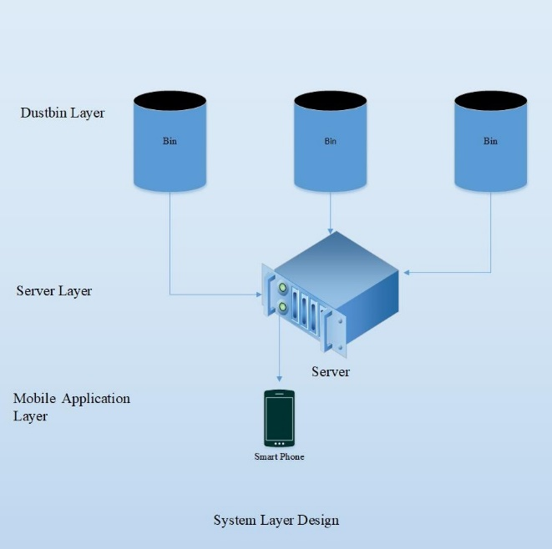

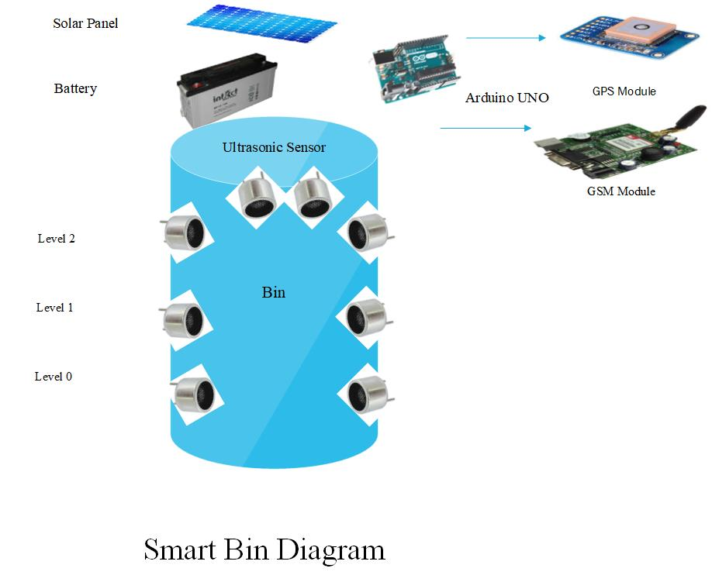

1. **ADVANTAGES**
2. Our System is fully Eco friendly, no external electric power supply is needed.
3. In our system if dustbin is relocated to another location it will automatically registered with the server with new GPS location.
4. It will save fuel and time using appropriate planning. Here we can use travelling salesman algorithm for route planning.
5. Our system store data for each bin dust consumption. Using this data later we can identify if the bin is suitable for the location. If dust amount is huge we can replace a bigger one or establish several bin in the location.
6. Our System also monitor the dust collector activities. Thus we can identify if they are efficient or not.
7. **CONCLUSION**

The main purpose of our system is handling the waste in smart way and make the environment clean. If the System is implemented properly it will really make the cities cleaner and greener. Furthermore it will lead our country one step ahead to make a smart city dream.

**REFERENCES**

[1] Monika K A, Nikitha Rao, Prapulla S B, and Shobha G, “Smart Dustbin-An Efficient Garbage Monitoring System” International Journal of Engineering Science and Computing, Volume 6 Issue No.6, June 2016

[2] Mokshada V. Patil, and Snehal M. Gajbhiye, “A Review on Internet of Things Based Garbage Bins Detection Systems” International Journal of Science and Research, Volume 6 Issue 4, April 2017

[3] Bikramjit Singh, and Manpreet Kaur, “Smart Dustbins for Smart Cities” International Journal of Computer Science and Information Technologies, Vol. 7(2), 2016, 610-611, ISSN: 0975-9646